**CSE250 Database Management System**

**Project Title:**

**Movie ticket booking system**

**Group Details:**

| Name | Enrolment no. |
| --- | --- |
| Harshrajsinh Vaghrola | AU2040195 |
| Manan Vadaliya | AU2040264 |
| Pruthviraj Dodiya | AU2040175 |
| Mitsu Sojitra | AU2040157 |

### **A)** **Project Description:**

This PHP movie ticket booking system project is primarily concerned with dealing with clients, theater management, and other aspects of the management side. In addition, if a consumer does not have an account, the system allows them to login or register. Client-side, admin panel, and theater panel are the three sections of the project. Customers can check the number of available movies, upcoming movies, and top movie trailers of each in an overview of this website (referring to client-side). More specifically, the system provides show specifics for each if they are accessible, after which the customer may simply select show timing and number of tickets before moving to the payment portion.

**Admin Panel:**

An administrator can view all of the movies currently showing in theaters and remove them. He or she can upload information on upcoming films by entering information such as the title, cast, release date, storyline summary, specific trailer, and movie poster. Furthermore, the administrator has access to the list of upcoming movie releases. He or she must fill in the title, release date, descriptions, cast information, and poster image for the upcoming film (if available). The admin interface for this online movie ticket buying system has limited functions, whereas the main role is played by the theater management side, which is briefly described below.

**Entities:**

* Login
* Bookings
* Theater
* Movie
* Shows
* Screens
* Contact
* Show_time
* Registration

**Available Features:**

* Client-Side
* Admin Panel
* Theater Panel
* Customer registration
* Recent movies
* Make bookings
* Booking history
* Movie arrangement
* Show management
* Arrange movie screens and show timings
* Start and Stop running shows

### 

### 

### **B) ER Diagram**

(<https://miro.com/welcomeonboard/Z0RXbTIzNUJaZ0lKbDZHOXRtWmYyb2FmVXJaZzZQQ2VubHNWVVhjNUo1SE50eW5sbExIOGJHcE9hbEdrZmdRZHwzNDU4NzY0NTI0ODA3NjY1NTIx?share_link_id=525783022378>)

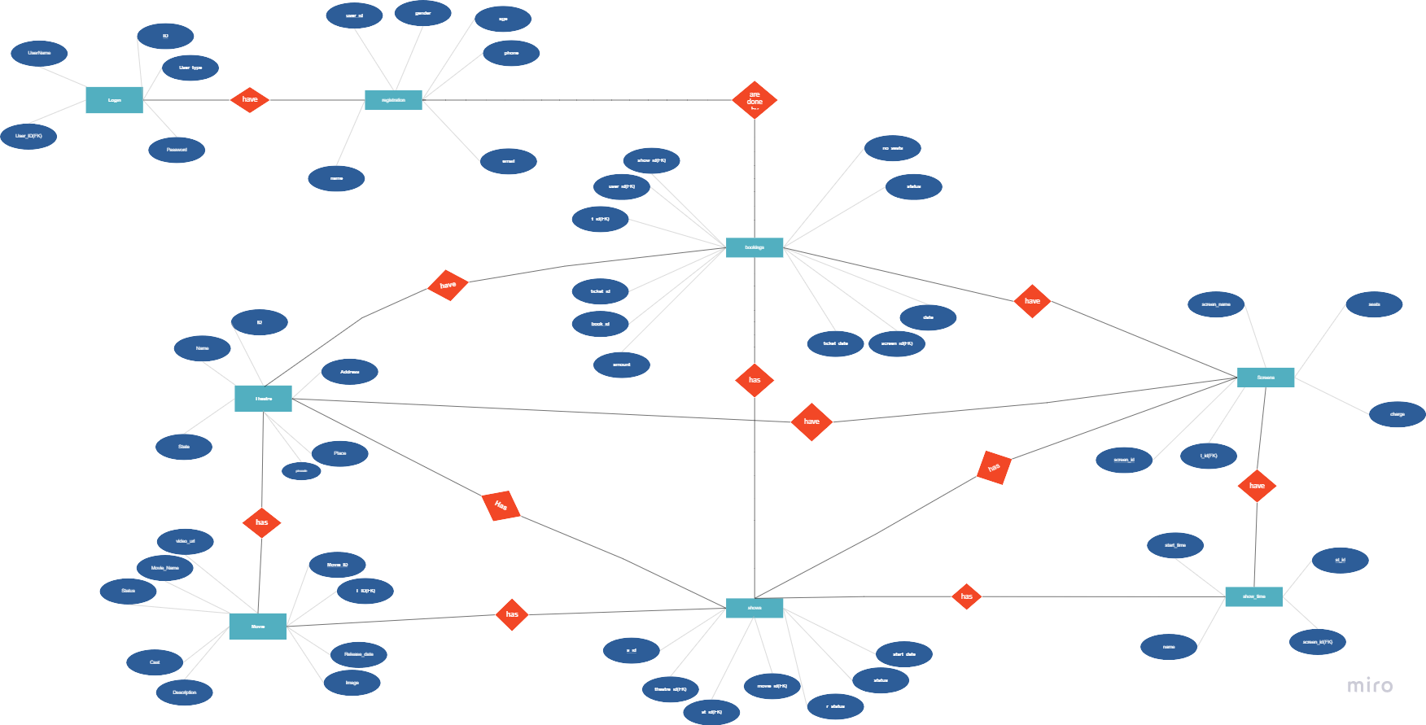

### 

### 

### 

### 

### 

### **C) Table Design**

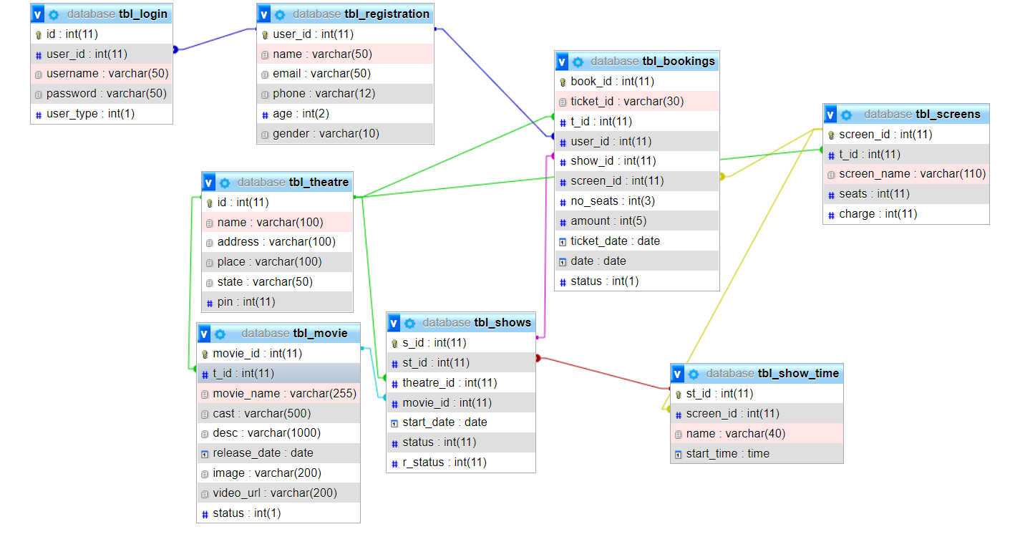

### **D) Functions**

Function 1

This function gives total amount of cost with respect to number of ticket

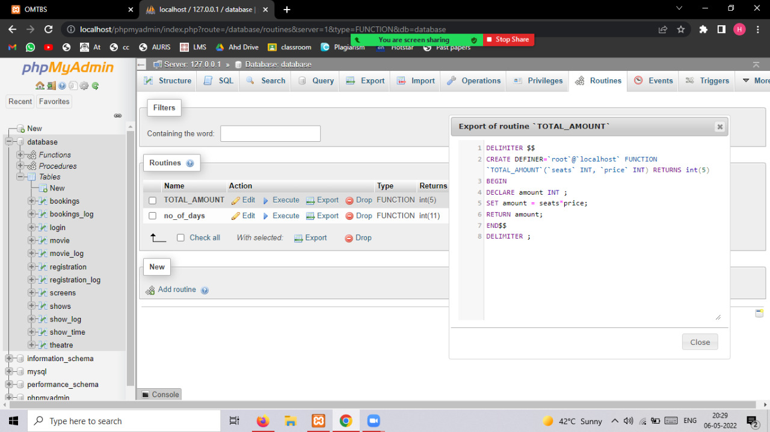

function output 1

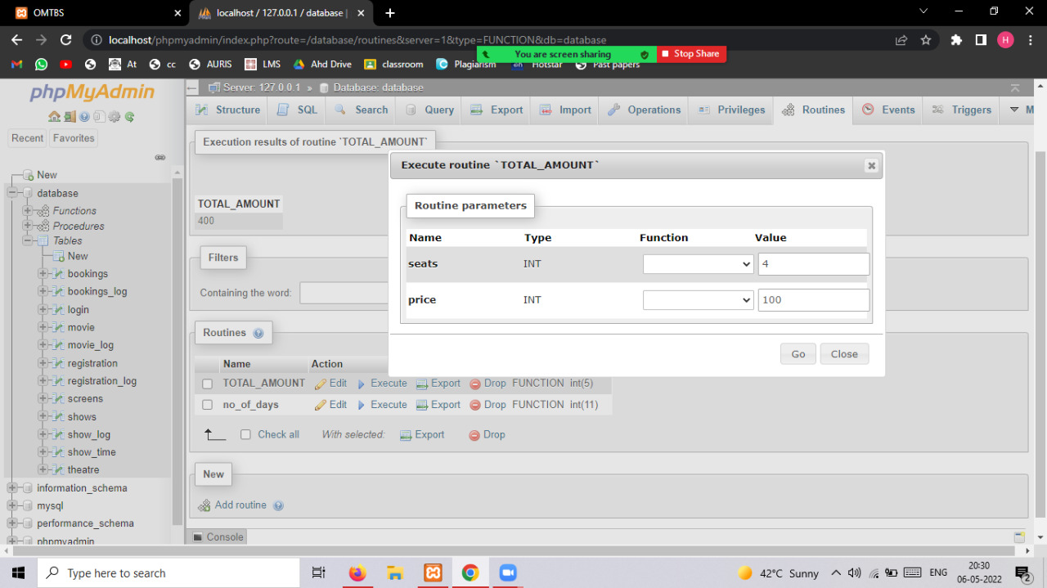

Function 2

This function gives number of screening days in cinema by subtracting the current date with release date

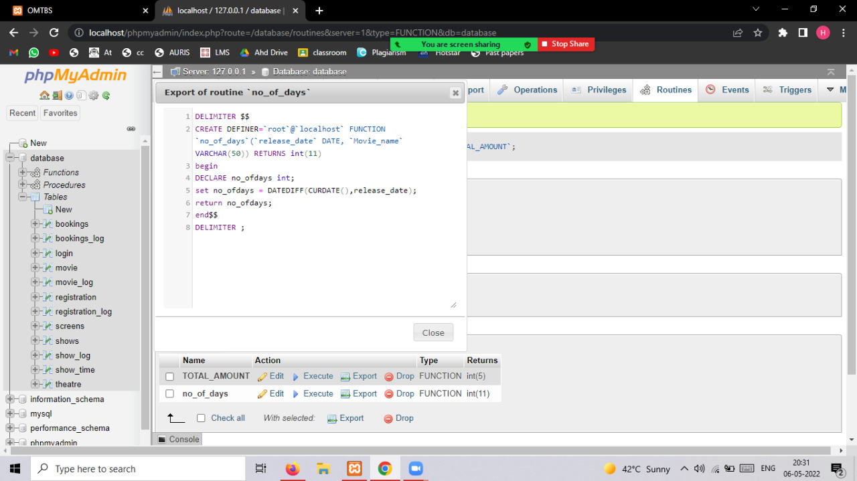

Function 2 output

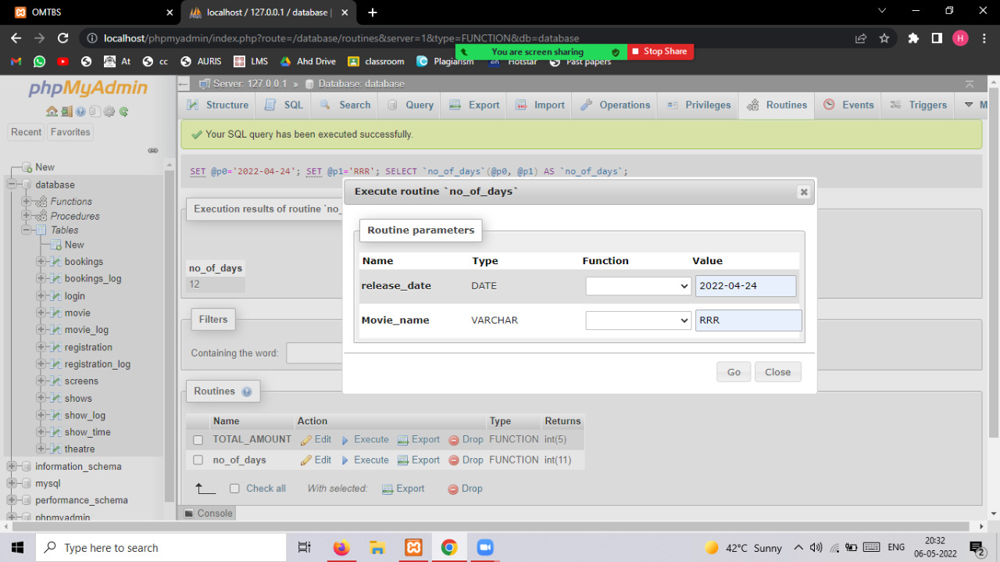

### 

### **E) Procedures**

Procedure 1) check status :

This procedure gives the count of shows which are on screen when st is 1 and count of shows which are not screening when st is 0 and st is show status

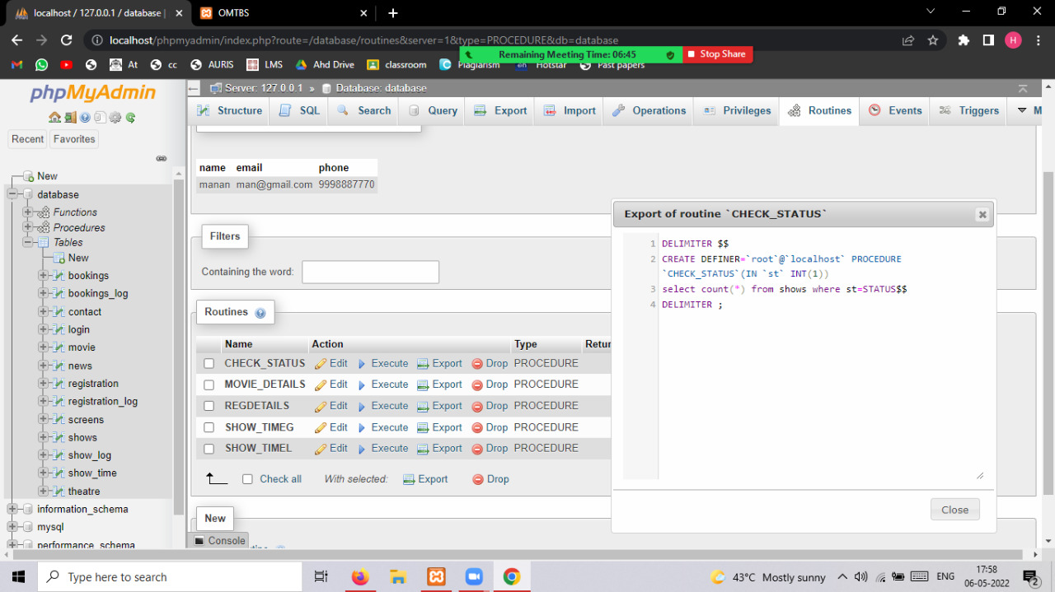

check status output

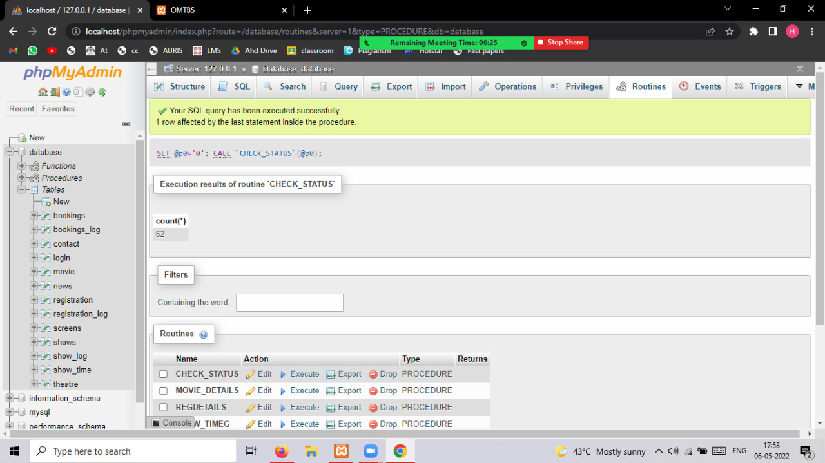

Procedure 2) movie detail

This procedure gives us movie details by movie id

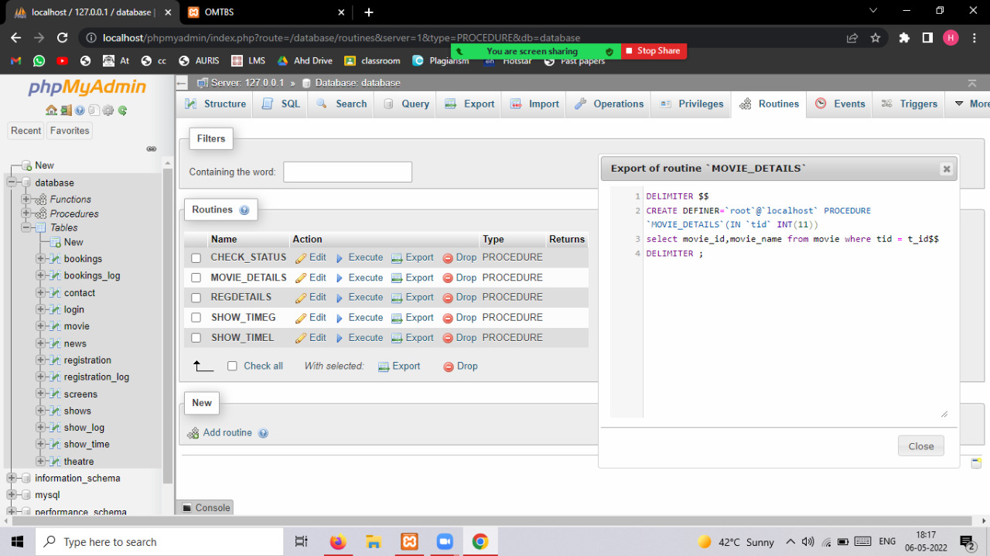

movie detail procedure output

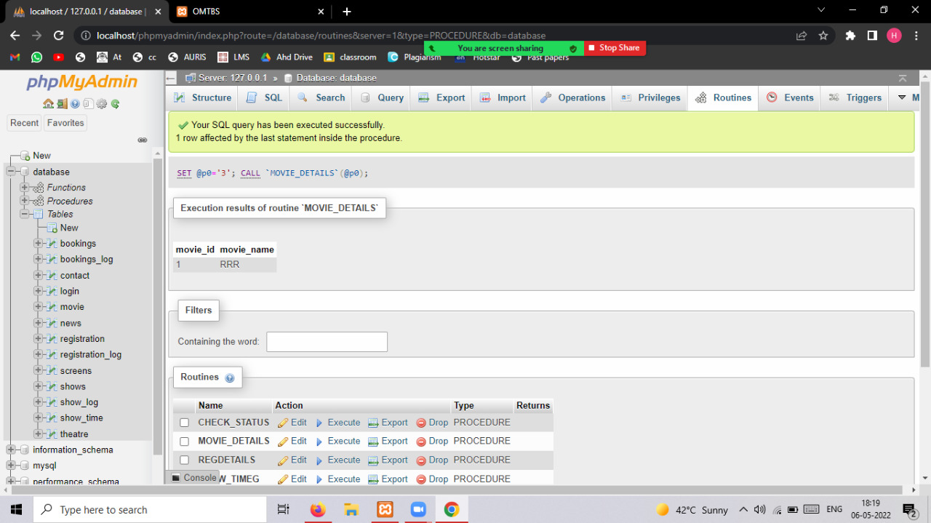

Procedure 3) reg details

This procedure provide all the necessary details of user by giving user id

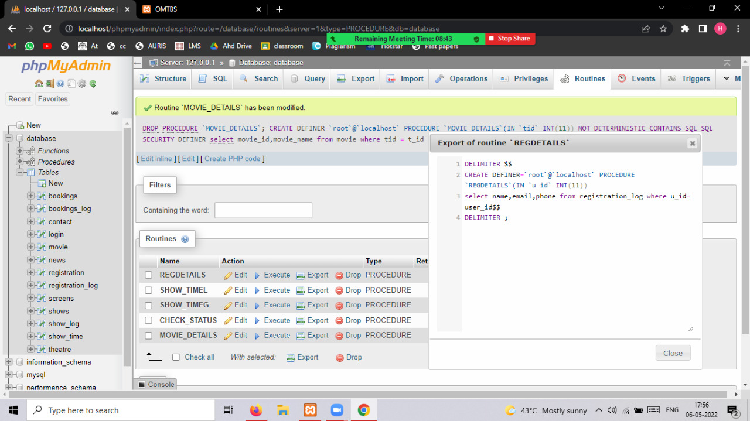

Procedure reg details output

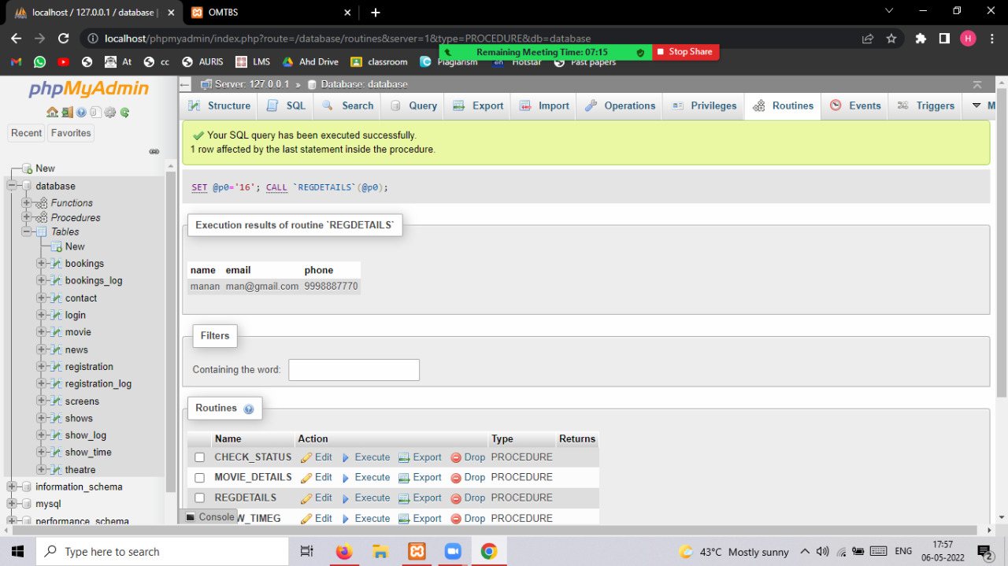

Procedure 4) show time Greater than by specific time

A procedure which gives count of shows after given time

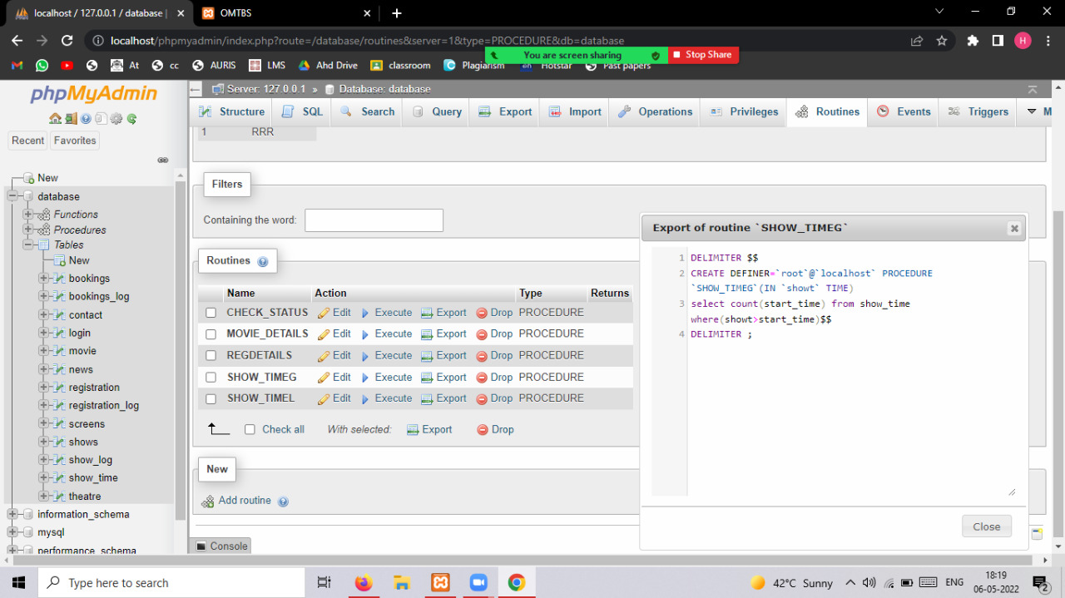

output of procedure showtime greater than by specific time

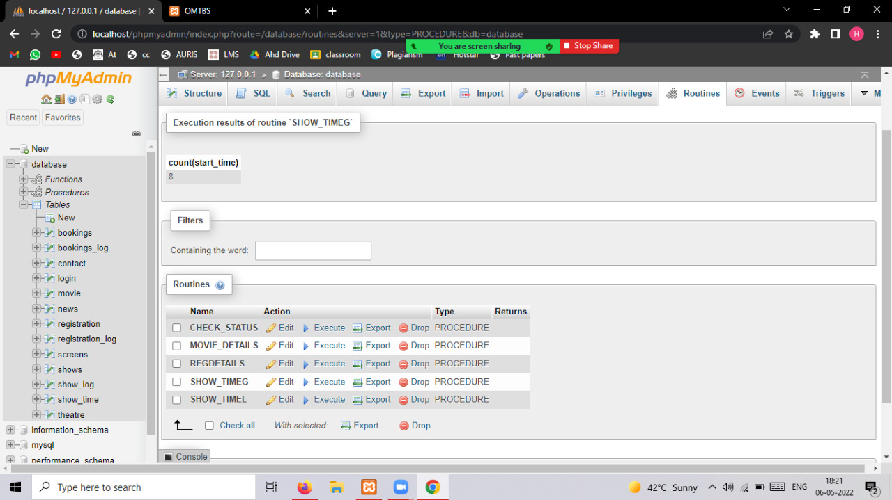

Procedure 5) showtime less than by specific time

A procedure which gives count of shows after given time

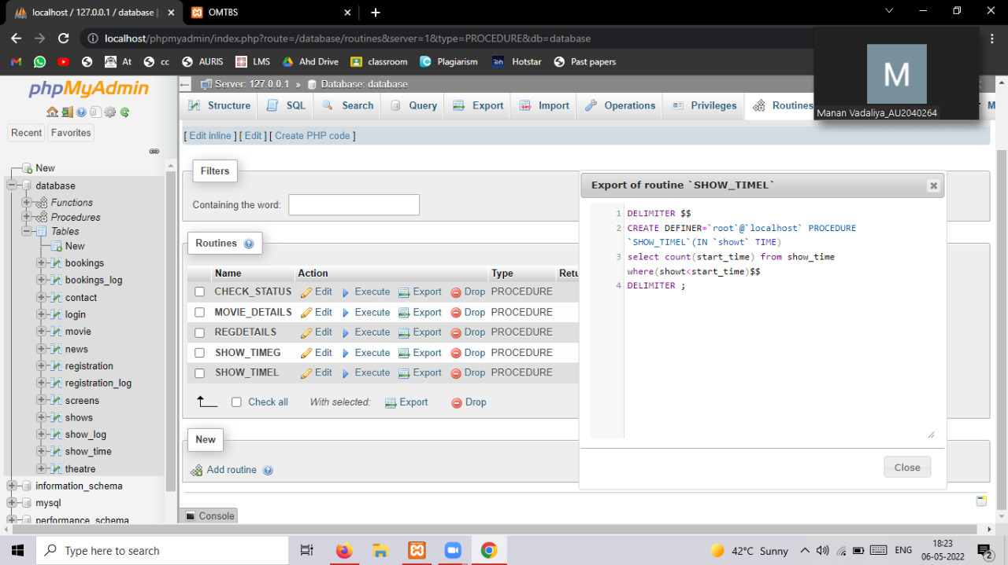

Output procedure showtime less than by specific time

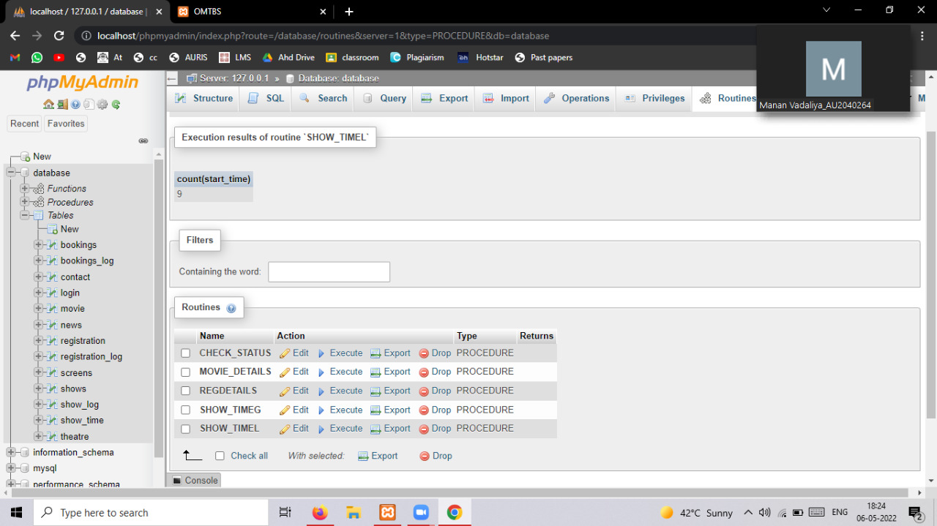

### **F) Triggers**

Trigger_1 Registration log: After inserting a record in registration table we get a new record automatically stored in registration log with data of user_id,name,email,phone number

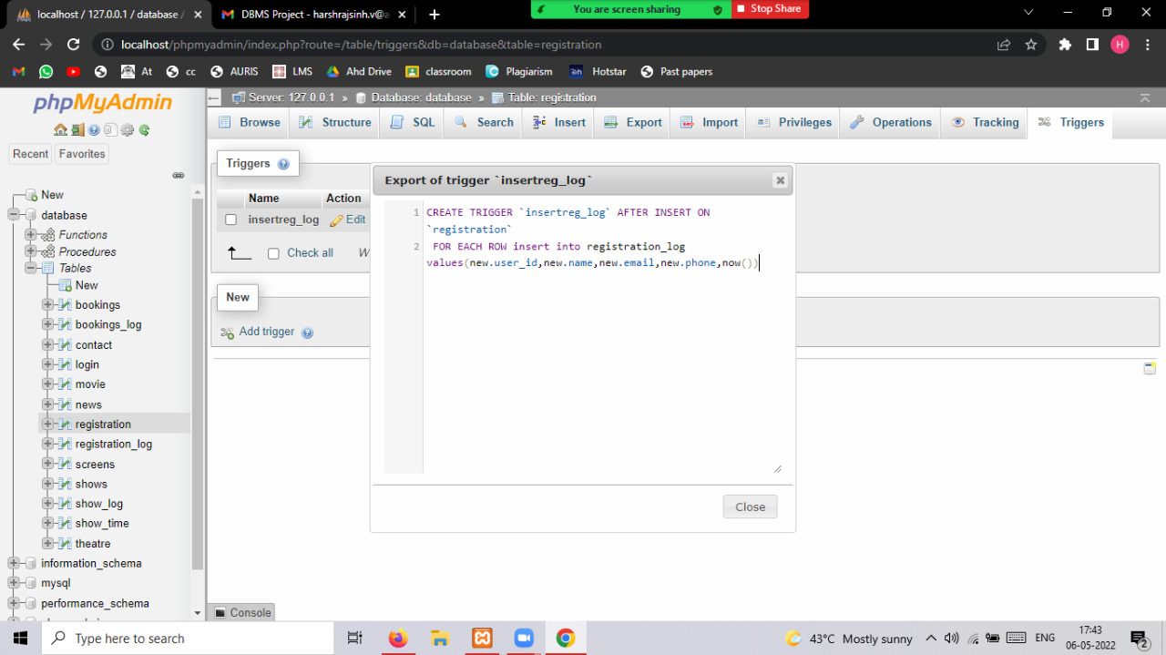

Trigger 1 output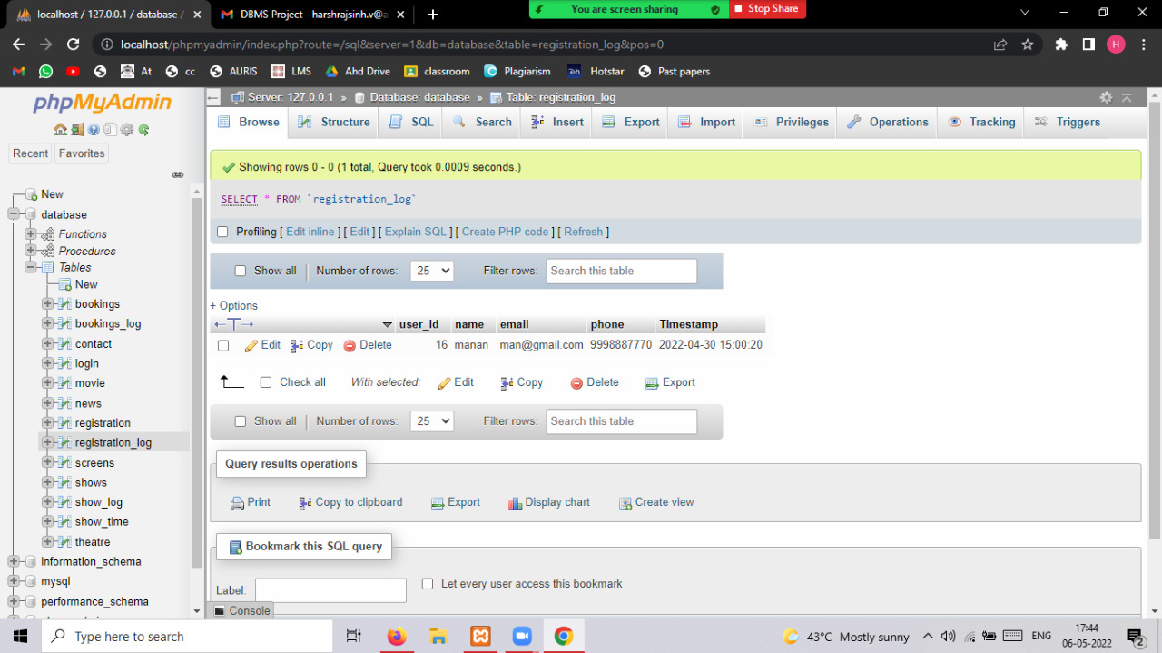

Trigger 2 Insert Show log:

After inserting a record in shows table we get a new record automatically stored in show log with data of st_id,theatre_id,movie_id,start_date,status,r_status

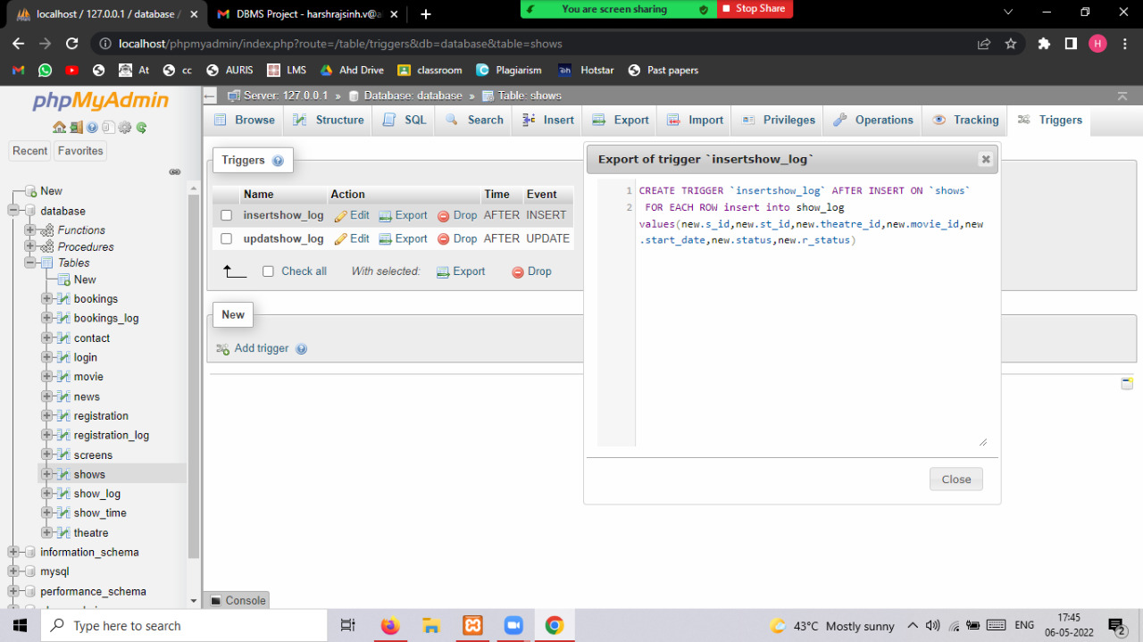

output Insert show log

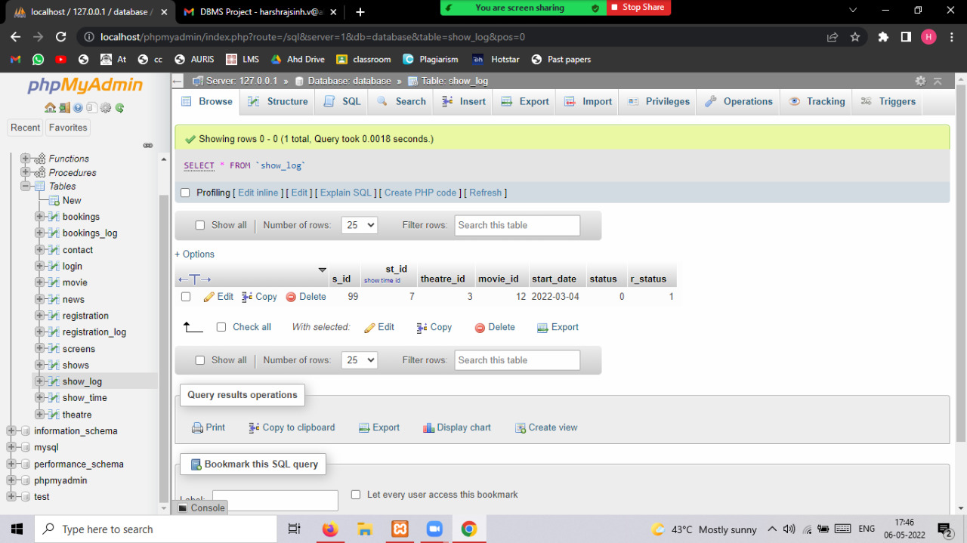

Trigger 3 Update show log:

After updating a record in the shows table we get a new record automatically stored in the show log with data of s_id,st_id,theatre_id,movie_id,start_date,status,r_status.

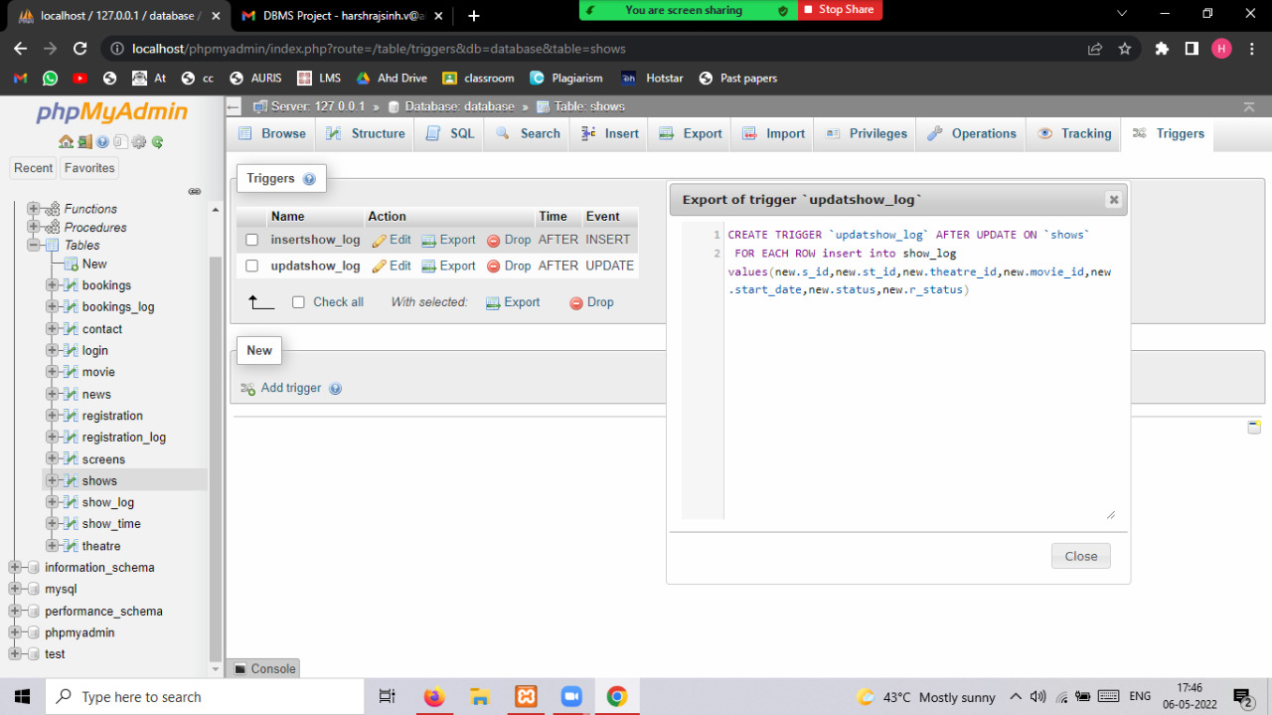

output of trigger Update



Trigger 4 Movie Log trigger:

After inserting a record in the movie table we get a new record automatically stored in movie log with data of movie_id,t_id,release_date.

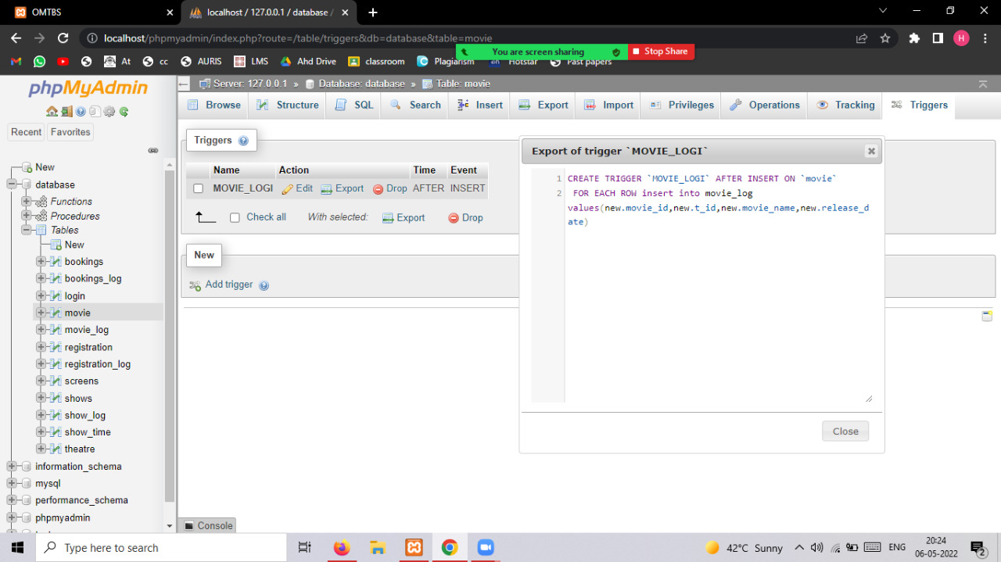

Movie log Insert trigger output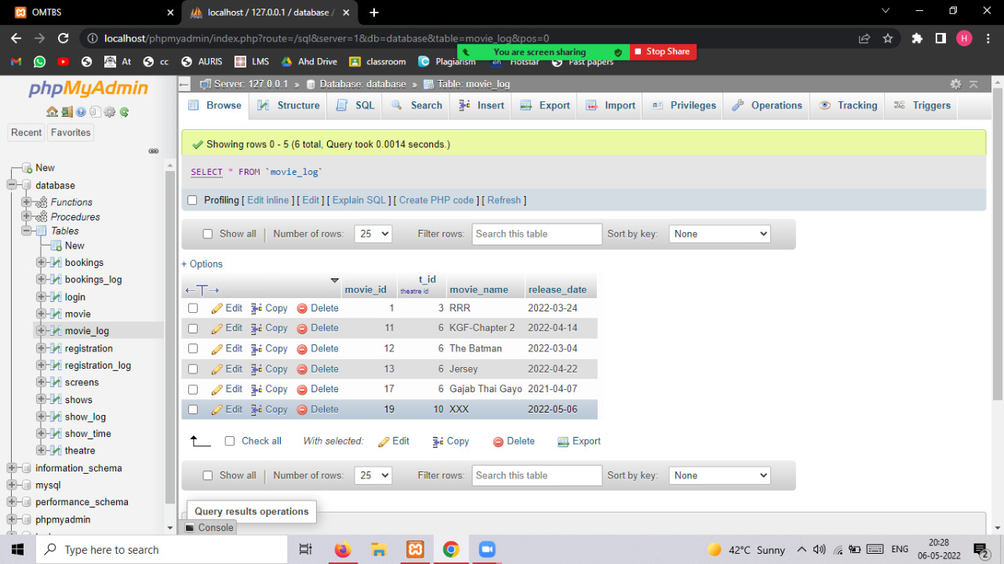

Trigger 5 Movie log delete trigger output

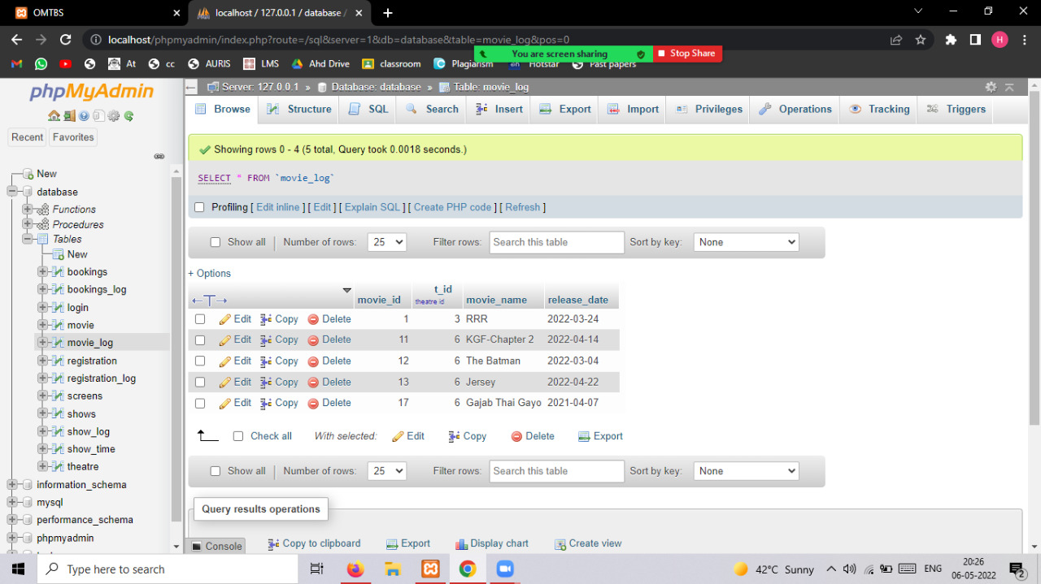

Trigger 6 booking trigger:

After successful booking a record is inserted in booking table we get a new record automatically stored in show log with data of book_id,ticket_id,t_id,use_id,show_id,screen_id,no_seats,amount,ticket_date

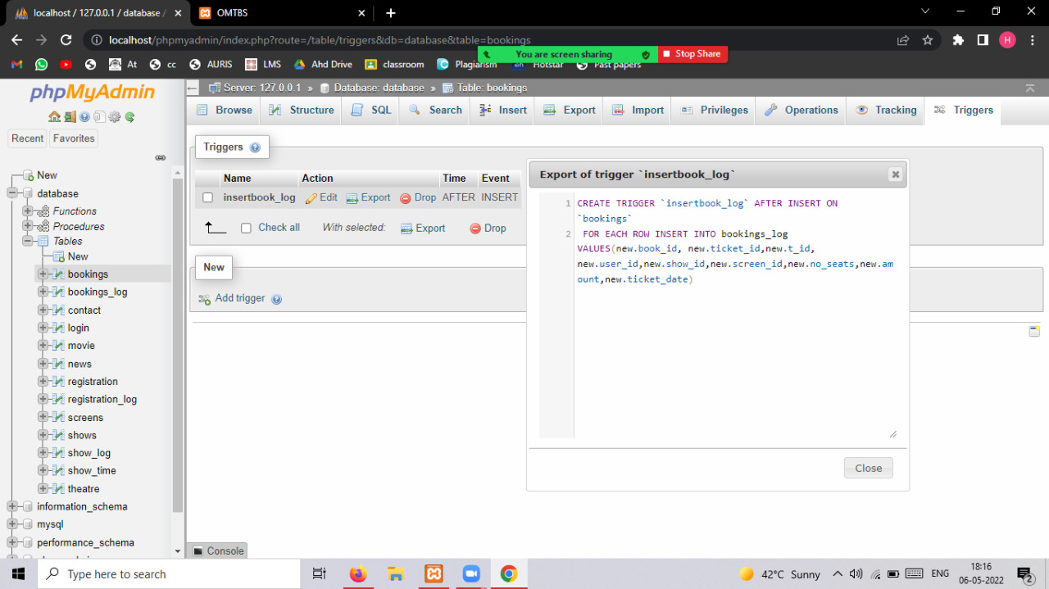

booking trigger output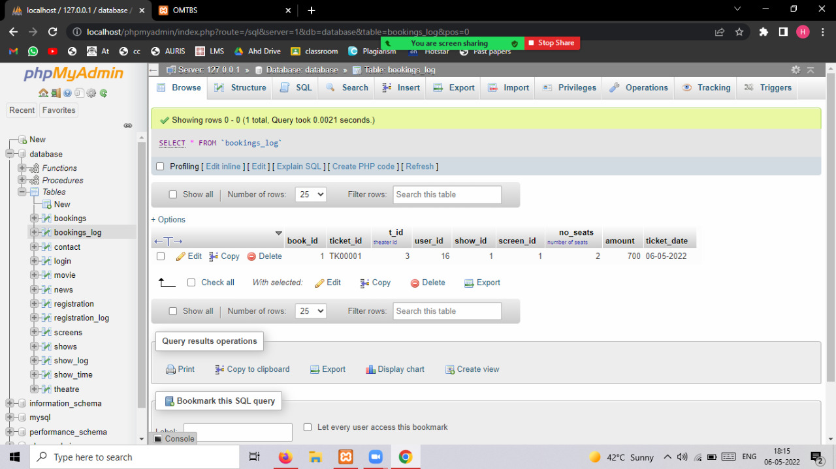

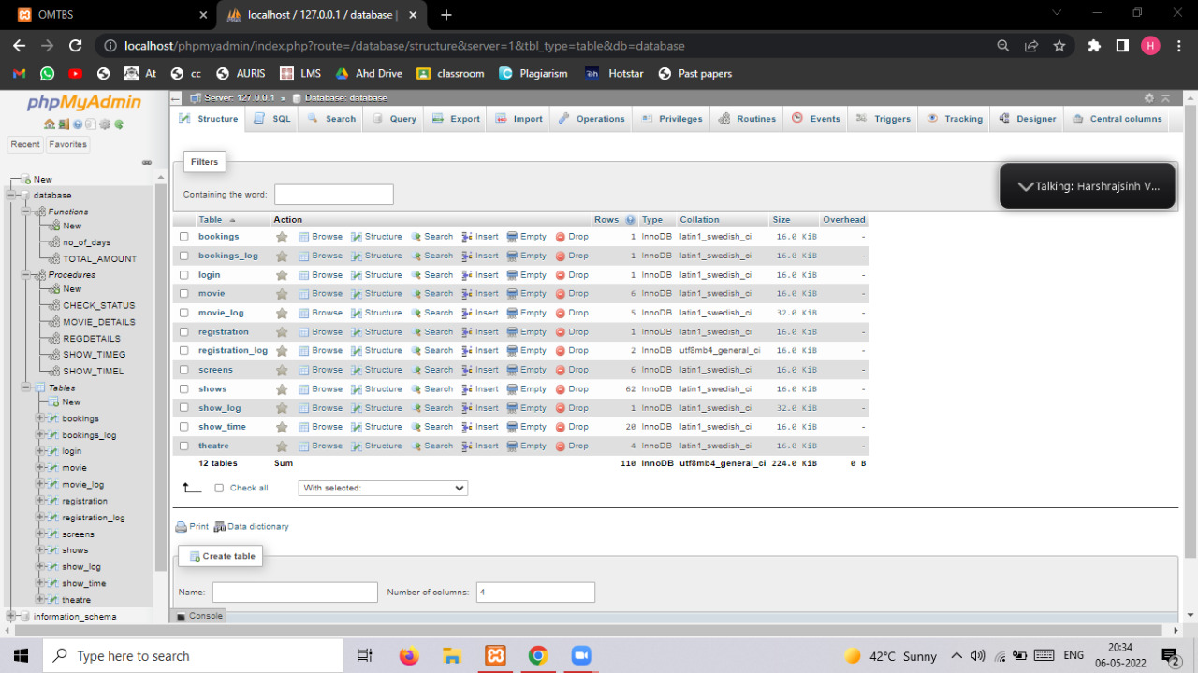

Table

### **Fronted Part**

Login Page

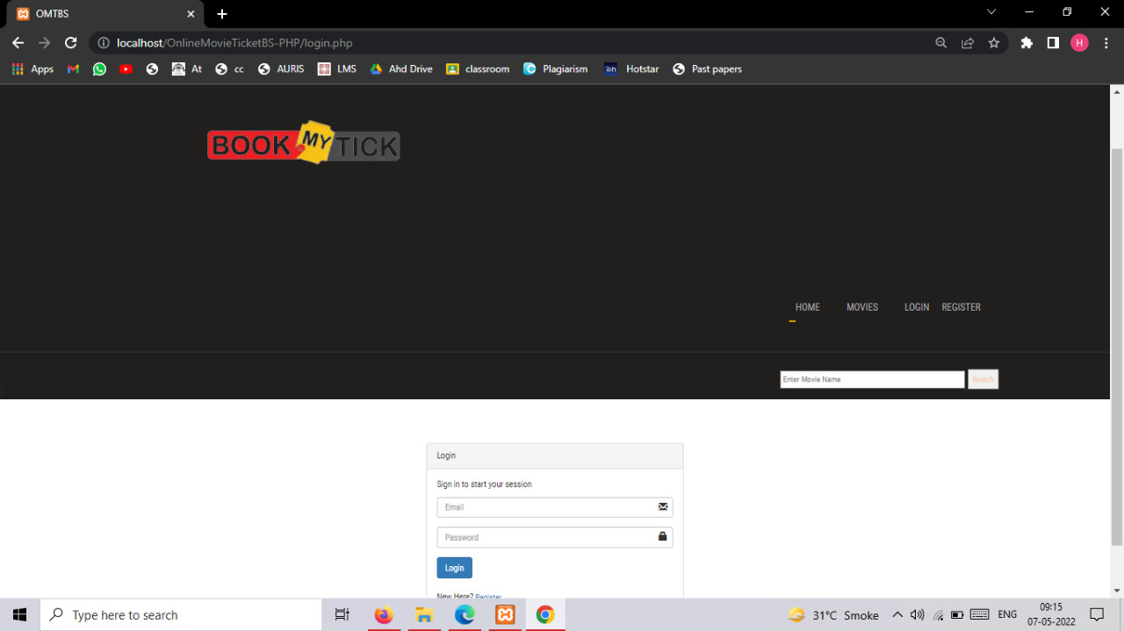

Registration page

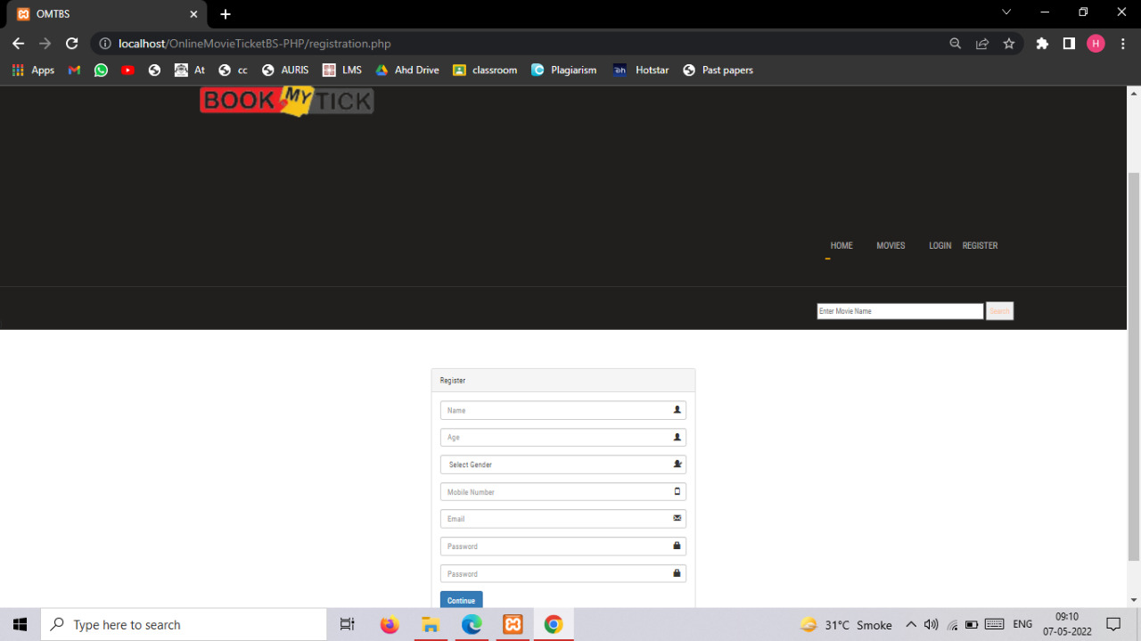

Showing movies

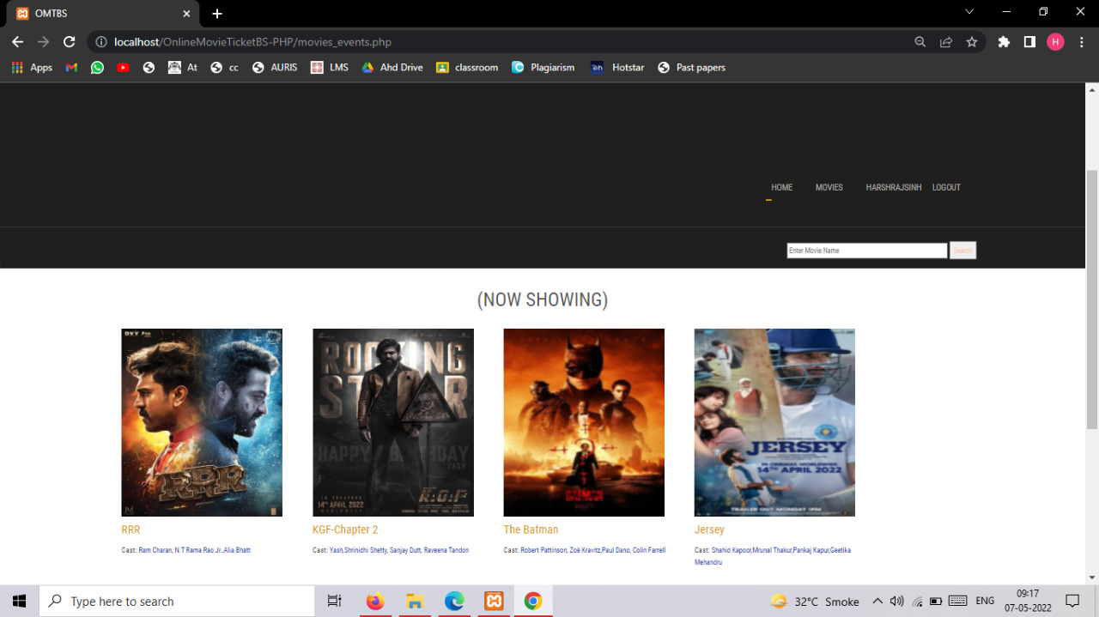

Movie details page

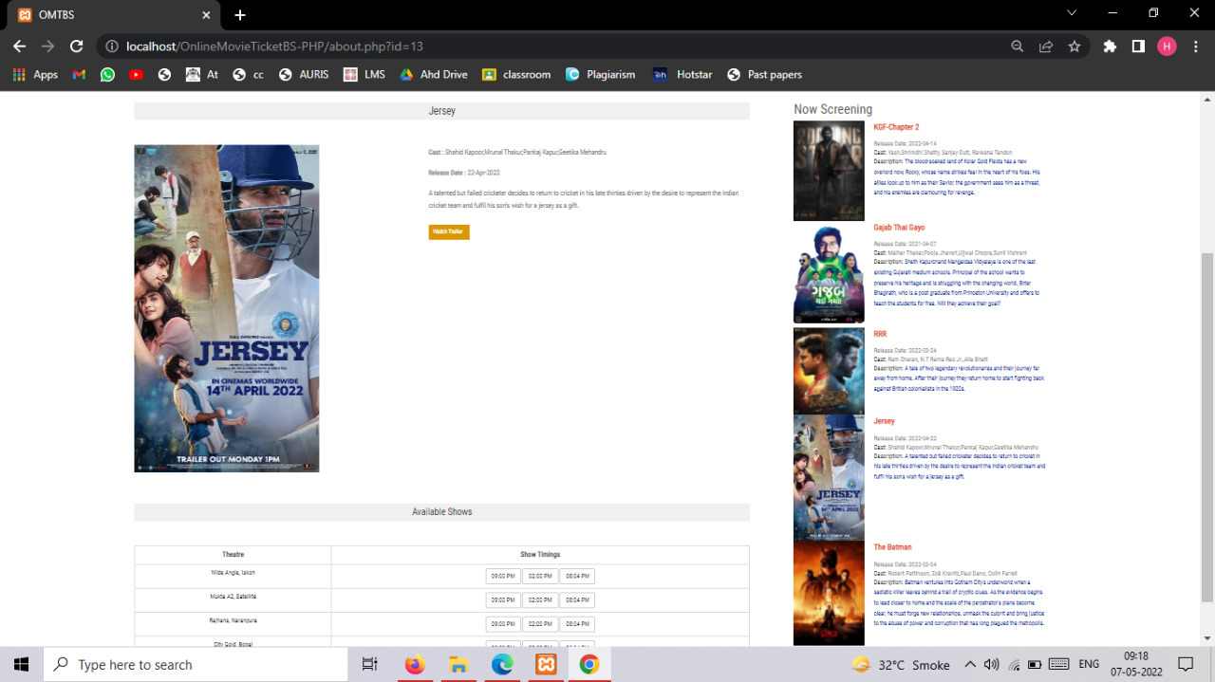

Available shows page

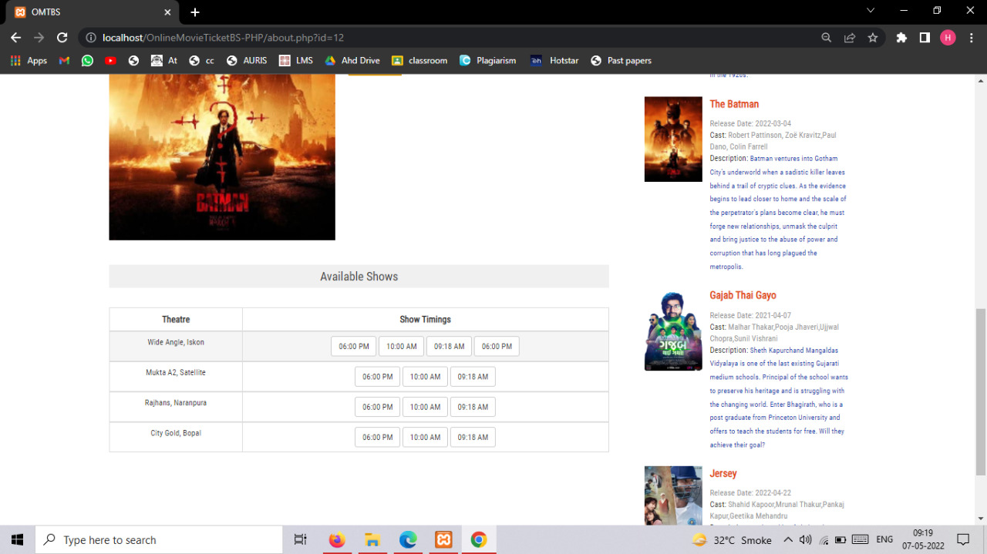

Booking page

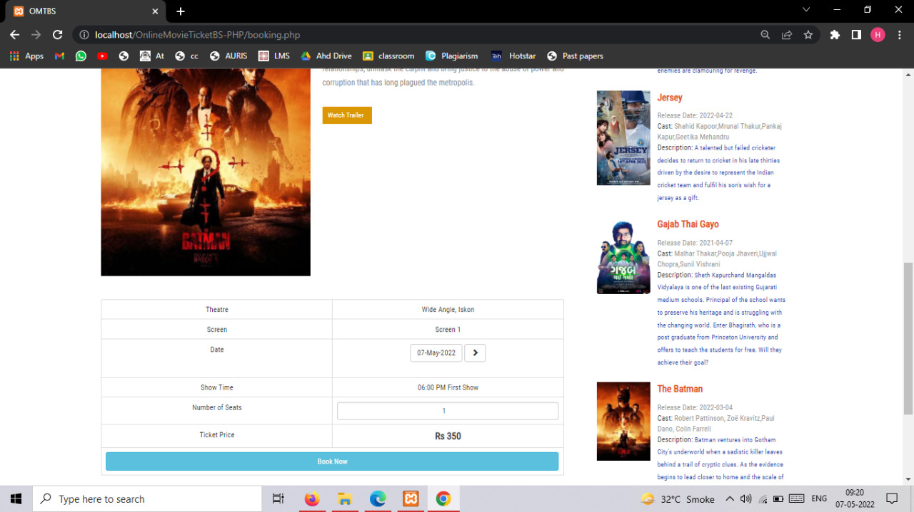

Final ticket printed page

